this event is triggered when the user tries to execute the report. The selection screen process that says, hey if your program has an out-selection screen event, let's execute that code before we go on to the report processing itself.

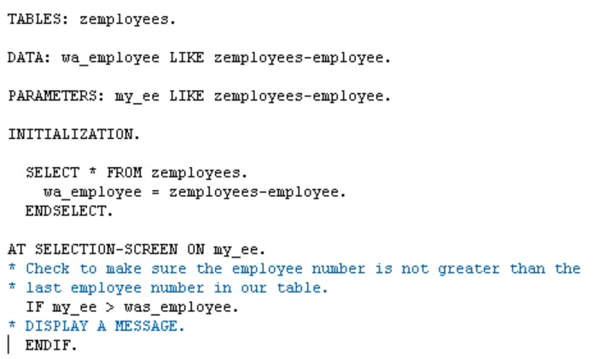

the at selection screen is the ideal place for us to check what value the user entered into the screen for the employee number selection field.